|  |  |
| --- | --- |
| ITB logo portrait B&W | INSTITUTE OF TECHNOLOGY BLANCHARDSTOWN  A Taster of Computing  [[VERSION – Unity 2D – C# language]] |

Gravity Guy 2D (2014) - a little computer game...

Part 4 – a full game is completed …

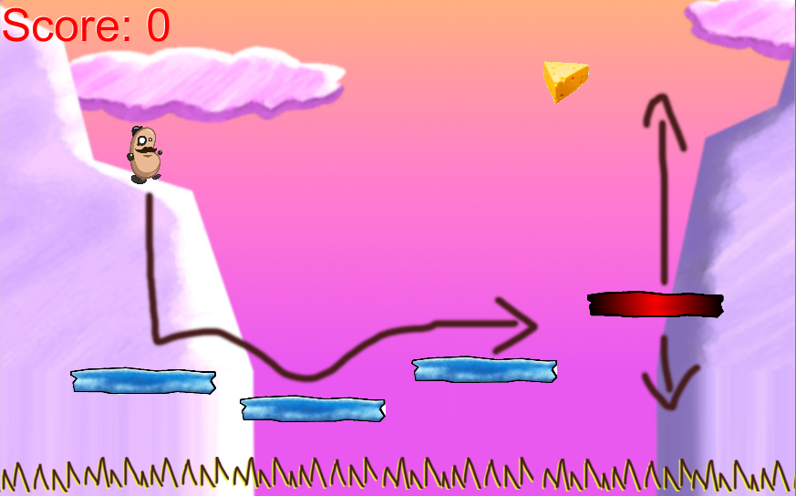

Welcome to “Gravity Guy”. In this multimedia programming exercise you will create a little 2D computer game.

CONTENTS

1 Recap, and aims of this part of the tutorial 3

2 Play a sound when a piece of food is eaten 4

3 Respawn the hero character when it falls down too low … 8

4 Separate the GUI ‘view’ from the Player ‘model’ 9

5 Add killer ‘spike’ objects to the scene 11

6 Add a ‘game over’ scene to our project (for when all lives lost) 14

7 Congratulations … 21

# Aims of this part of the tutorial

## New features / skills to be learned in this part of the tutorial

In this part of the tutorial you will add the following features to our game:

* *Win game* 
  + *Eat all the cheese – need to know HOW MANY pieces of food …*
  + *GameObject[] wallObjects = GameObject.FindGameObjectsWithTag("*
  + *brick");*
  + *int numWallObjects = wallObjects.Length;*
* *Display scores using GUIText gameObjects, rather than scripted Labels*
* *Display in image for lives left*
* *Moving Camera script*
* *Background image (move with camera?)*
* *Timer*
* *Data driven …*

*Extras:*

* *Solve the ‘lose 2 lives at a time problem’*
  + *nextLoseALifeTime*
    - *can’t lose more than 1 live per second …*
    - *nextLoseALifeTime = Time.time + 1;*
    - *if( Time.time > nextLoseALifeTime) then lives-- …*

## Playtest your game

When player hits spikes, the ‘die’ sounds should play, when player hits cheese, the ‘yum’ sound should play – simples!

# Congratulations …



**Congratulations**

**You have now completed Gravity Guy!**